Falcon Parents,
The Rank One online forms are now available. This is for all students interested in trying out and/or participating in any sport we offer at Fort Settlement Middle School. Click on the link below to access directions as well as the forms. Remember you will need the students name along with their student ID number to submit the forms. Make sure to include a zero (0) in front of the student ID number. Below you will find a guide to help you get started. Physical forms must still be turned into your athletic coordinators while all other required forms are available through this new website.
All students wishing to tryout/participate in Athletics must have all forms submitted!
https://fortbendisd.rankonesport.com
If you have already submitted you athletic packet to a coach, that is fine.
Thank you for your time and support!

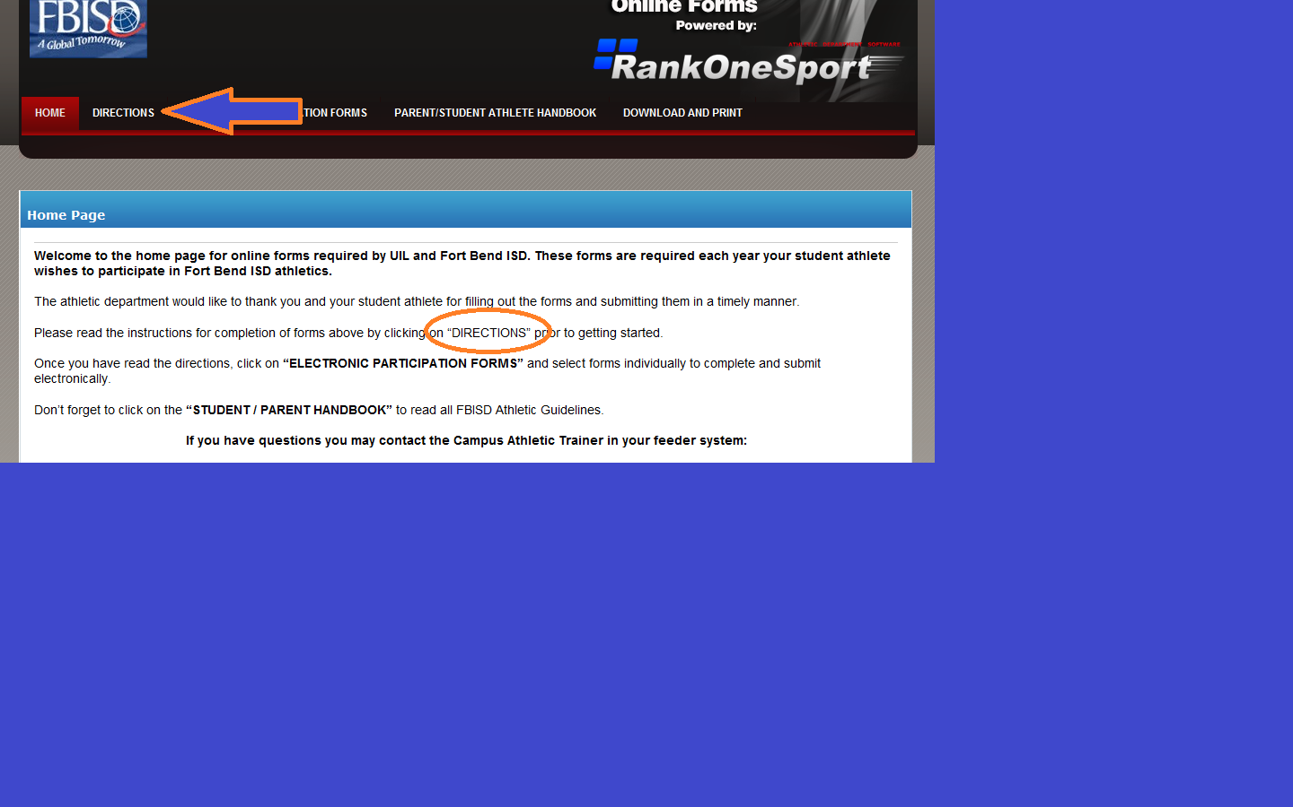
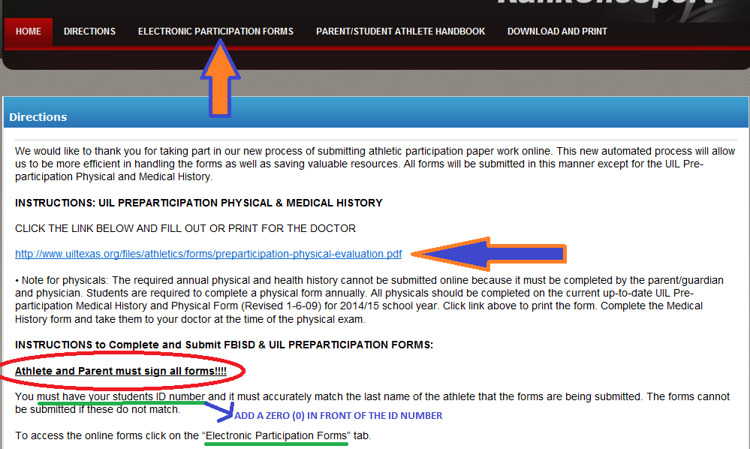
Now you may click on the electronic participation forms and begin submitting information. Don’t forget signatures!! All forms must be completed to participate.

Further directions on next page.

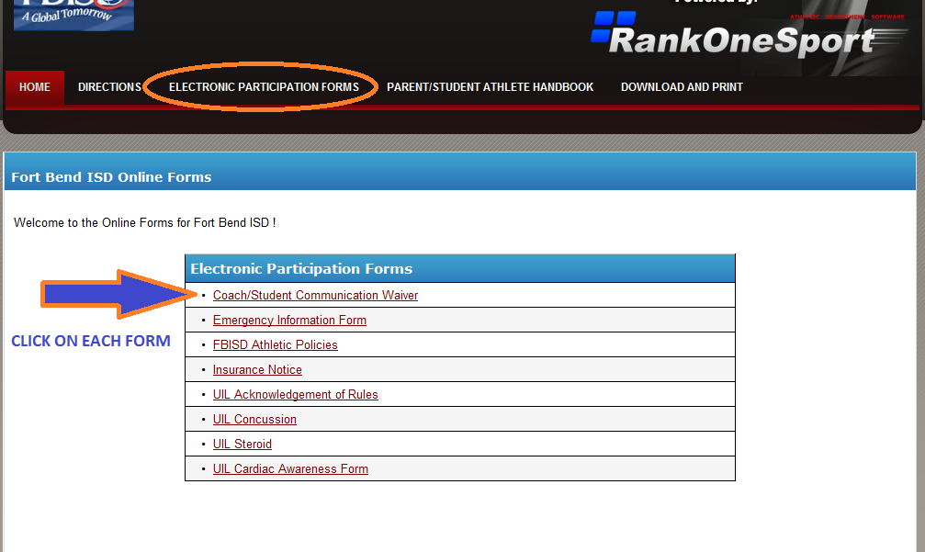
Once you have completed the form you must click the submit button to send it to the website and so your athletic coordinator may approve.
